SIMATS ENGINEERING (SAVEETHA SCHOOL OF ENGINEERING)
Department of Computer Science and Engineering
CO2 ASSESSMENT TOOL 2 – Architecture Design Assignment

Course Code: | CSA10 / CSA1063 | Course Title: | Software Engineering
CO Assessed: | CO2 | Assessment: | Assessment Tool 2 – Architecture Design Assignment
Weightage: | 20% | Total Marks: | 25
CO2 Statement: | Perform detailed requirements analysis, design scalable architectures, and prioritize features with a focus on cross-disciplinary skills
Student Name: | P ROHINI | Reg. No.: | 192524147
Date: | 30-07-2026 | Duration: | 60 minutes

Code of Conduct
I P ROHINI (192524147) (Name / Reg No) certify that this submission is my original work and that I have adhered to the guidelines specified for this assessment. I understand that any violation of academic integrity rules will result in disciplinary action.
Signature of the Student: P ROHINI
Annexure A – Architecture Design Assignment
Instructions to Students:
Each student will be assigned an individual software project problem statement. Based on the assigned problem, analyze the system requirements and design an appropriate software architecture by applying software engineering principles. Your submission should demonstrate your ability to select, justify, and evaluate a suitable architectural style.

Question
Based on your assigned problem statement, perform an Architecture Design Analysis and prepare an architecture design report by answering the following questions:

1. Analyze System Requirements
- Study the given problem statement and identify the system objectives.
- Analyze the functional and non-functional requirements that influence the software architecture.
- Identify key quality attributes such as scalability, maintainability, reliability, availability, performance, and security.

2. Select a Suitable Software Architecture
- Select an appropriate architectural style for the proposed system (e.g., Layered Architecture, Client-Server, MVC, Microservices, Event-Driven, Service-Oriented Architecture, Serverless, or Hybrid Architecture).
- Justify why the selected architecture is the most suitable for the given problem.

3. Draw the Software Architecture Diagram
- Design a clear architecture diagram illustrating the overall structure of the proposed system.
- Include all major layers/components, databases, external systems, APIs, and communication mechanisms.
- Use appropriate software architecture notations and labels.

4. Explain Components and Their Interactions
- Describe the purpose and responsibilities of each architectural component.
- Explain how the components communicate and exchange data.
- Illustrate the overall workflow of the system.

5. Discuss Quality Attributes
Evaluate how the proposed architecture addresses the following aspects:
- Scalability
- Security
- Performance
- Reliability
- Maintainability
- Availability

6. Justify Architectural Decisions
- Explain the rationale behind your architectural choices.
- Discuss the trade-offs considered while selecting the architecture.
- Explain how the chosen architecture supports future enhancements, system integration, and long-term maintainability.
Rubrics for Calculation
Evaluation Criteria | Excellent (4 Marks) | Good (3 Marks) | Satisfactory (2 Marks) | Needs Improvement (1 Mark)
System Requirement Analysis | Thoroughly analyzes the problem statement, accurately identifies functional and non-functional requirements, and clearly explains quality attributes influencing the architecture. | Analyzes most requirements with minor omissions or limited explanation. | Identifies only basic requirements with partial analysis. | Requirement analysis is incomplete, inaccurate, or lacks clarity.
Selection of Software Architecture | Selects the most appropriate architectural style with strong technical justification aligned to system requirements. | Selects a suitable architecture with reasonable justification. | Architecture is partially suitable with limited justification. | Inappropriate architecture selected or justification is missing.
Architecture Diagram and Component Design | Produces a clear, complete, and well-structured architecture diagram with all major components, interfaces, and interactions accurately represented. | Diagram is mostly complete with minor omissions or notation issues. | Diagram includes only essential components and lacks sufficient detail. | Diagram is incomplete, unclear, or technically incorrect.
Component Interaction and Quality Attribute Analysis | Clearly explains component responsibilities, interactions, and thoroughly discusses scalability, security, performance, reliability, maintainability, and availability. | Explains most components and quality attributes with minor gaps. | Provides limited explanation of interactions and addresses only some quality attributes. | Component interactions and quality attributes are poorly explained or missing.
Architectural Justification and Technical Presentation | Provides strong justification for architectural decisions, discusses trade-offs and future enhancements, and presents a well-organized, professional report. | Provides adequate justification with minor gaps; report is well organized. | Limited justification with minimal discussion of trade-offs or future scope; report needs improvement. | Justification is weak or absent; report lacks organization and technical clarity.

Criteria | Mark
System Requirement Analysis | /5
Selection of Software Architecture | /5
Architecture Diagram and Component Design | /5
Component Interaction and Quality Attribute Analysis | /5
Architectural Justification and Technical Presentation | /5
TOTAL | /5

CO2-ASSISSMENT TOOL-2
COURSE CODE: CSA1007
COURSE NAME: SOFTWARE ENGINEERING
NAME: P ROHINI
REG NO: 192524147

35) Smart Urban Traffic Congestion Prediction and Signal Optimization Platform
Industry Context
The transportation sector is rapidly adopting digital technologies to improve efficiency, safety, scalability, and decision making. Traditional approaches often rely on manual processes and reactive monitoring, resulting in delays, increased operational costs, resource wastage, and reduced service quality. There is a growing need for an intelligent, cloud-enabled, distributed platform capable of collecting real-time IoT and enterprise data, analyzing operational conditions, predicting risks, and supporting timely interventions.
Problem Statement
Design and develop a distributed Smart Urban Traffic Congestion Prediction and Signal Optimization Platform that continuously acquires real-time operational data from connected devices, enterprise systems, and users. The platform should detect abnormal events, generate predictive insights using AI/ML, notify stakeholders in real time, provide centralized dashboards, generate reports, and support secure, scalable, fault-tolerant operation across multiple locations.

Objectives
• Collect real-time operational data.
• Monitor system performance continuously.
• Detect anomalies automatically.
• Predict failures or risks using analytics.
• Notify stakeholders immediately.
• Generate dashboards and reports.
Architecture Design Analysis

Project Title
Smart Urban Traffic Congestion Prediction and Signal Optimization Platform

1. System Requirement Analysis
System Objectives
The objective of the Smart Urban Traffic Congestion Prediction and Signal Optimization Platform is to develop a distributed, cloud-based system that collects real-time traffic data from IoT devices, cameras, GPS systems, and enterprise applications. The system uses Artificial Intelligence (AI) and Machine Learning (ML) techniques to predict traffic congestion, optimize traffic signal timings, notify stakeholders about abnormal events, and provide centralized dashboards and reports.
Functional Requirements
- Collect real-time traffic data from IoT sensors, cameras, GPS devices, and weather services.
- Detect traffic congestion, accidents, and abnormal events automatically.
- Predict future congestion using AI/ML algorithms.
- Optimize traffic signal timings dynamically.
- Send notifications and alerts to traffic police, emergency services, and city administrators.
Non-Functional Requirements
- High scalability to support multiple cities and intersections.
- High performance with low response time.
- High availability for continuous system operation.
- Reliable prediction and data processing.
- Secure communication and data storage.
- Easy maintenance and future enhancement.
- Fault tolerance to avoid service interruption.
Quality Attributes
- Scalability: Supports a growing number of users, sensors, and traffic intersections.
- Performance: Processes and analyzes traffic data with minimal delay.
- Reliability: Ensures accurate predictions and uninterrupted services.
- Availability: Operates continuously (24×7) without significant downtime.
- Security: Protects traffic data through authentication, authorization, and encryption.
- Maintainability: Allows easy updates and integration of new technologies.

2. Selection of Suitable Software Architecture
Selected Architecture
Hybrid Architecture (Microservices + Event-Driven Architecture)
Justification
A Hybrid Architecture combining Microservices and Event-Driven Architecture is the most suitable for this platform because it efficiently handles large volumes of real-time traffic data from distributed IoT devices.
The Event-Driven Architecture enables immediate processing of sensor events, while Microservices divide the application into independent services such as traffic monitoring, AI prediction, signal optimization, notification, reporting, and user management. This improves scalability, fault tolerance, maintainability, and performance.

3. Software Architecture Components
The proposed architecture consists of the following major components:
User Interface
Provides web and mobile applications for administrators, traffic police, and authorized users to monitor traffic conditions and manage the system.
API Gateway
Acts as the single entry point for all client requests and securely routes them to the appropriate microservices.
IoT Data Collection Service
Collects real-time traffic information from IoT sensors, CCTV cameras, GPS devices, and external APIs.
Traffic Monitoring Service
Continuously monitors traffic conditions and detects congestion or abnormal traffic events.
AI Prediction Service
Processes historical and real-time traffic data using machine learning algorithms to predict congestion and traffic risks.
Signal Optimization Service
Automatically calculates and updates traffic signal timings based on AI predictions.
Notification Service
Sends real-time alerts and notifications to stakeholders whenever congestion, accidents, or emergencies are detected.
Report Generation Service
Generates statistical reports and traffic analysis for decision-making.
User Management Service
Manages authentication, authorization, user accounts, and system roles.
External Systems
Includes traffic sensors, CCTV cameras, weather services, GPS systems, emergency services, and traffic police systems.
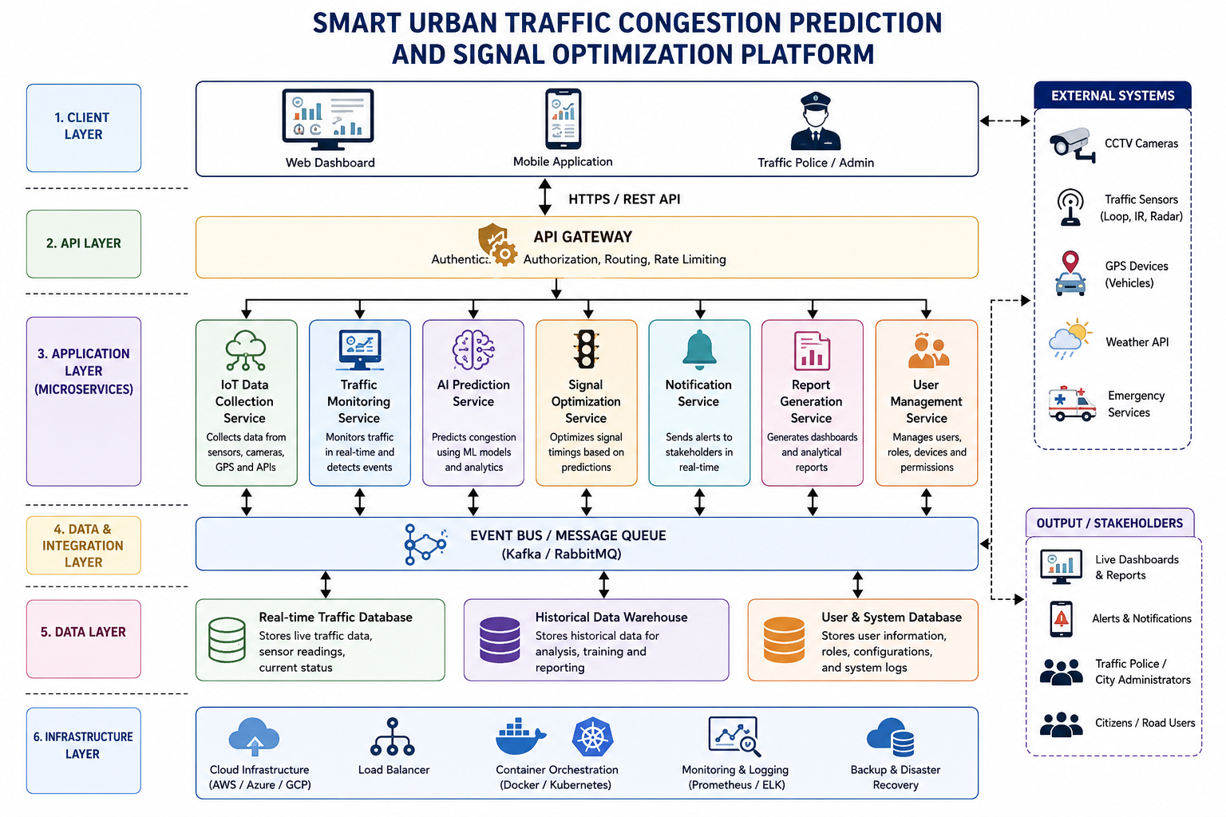

4. Component Interaction and Workflow
The platform continuously collects traffic data from IoT sensors, CCTV cameras, GPS devices, and external systems. The collected data is sent to the IoT Data Collection Service, where it is processed and forwarded to the Traffic Monitoring Service.
The Traffic Monitoring Service analyzes traffic conditions and forwards relevant information to the AI Prediction Service. Using AI and Machine Learning algorithms, the system predicts traffic congestion and identifies potential risks.
The prediction results are then sent to the Signal Optimization Service, which automatically adjusts traffic signal timings to improve traffic flow.

5. Quality Attribute Analysis
Scalability
The architecture supports horizontal scaling by allowing each microservice to be deployed independently. New traffic intersections, sensors, and users can be added without affecting the existing system.
Security
Security is maintained using user authentication, role-based access control, encrypted communication (HTTPS), secure APIs, and encrypted databases to protect sensitive traffic information.
Performance
Real-time event processing and distributed services minimize processing delays and provide faster responses during peak traffic conditions.
Reliability
The platform uses distributed services and independent modules to ensure reliable operation. Failure in one service does not affect the entire system.
Maintainability
Since each service performs a specific function, developers can update or modify individual services without impacting the remaining components.
Availability
Cloud deployment, load balancing, and service redundancy ensure continuous system availability with minimal downtime.

6. Architectural Justification
The Hybrid Architecture is selected because it satisfies all the functional and non-functional requirements of the Smart Urban Traffic Congestion Prediction and Signal Optimization Platform.
The Microservices architecture improves scalability, maintainability, and independent deployment of services, while the Event-Driven architecture enables fast processing of real-time traffic events.
Trade-offs
Advantages
- Supports real-time traffic monitoring.
- Highly scalable and fault tolerant.
- Faster data processing.
- Easy maintenance and updates.
- Supports cloud and distributed deployment.
Disadvantages
- More complex than a monolithic architecture.
- Requires additional infrastructure such as message brokers.
- Higher deployment and monitoring costs.
Future Enhancements
- Integration with autonomous vehicles.
- Smart parking management.
- Public transportation optimization.
- Emergency vehicle priority control.
- AI-based accident prediction.
- Digital twin simulation for smart city traffic planning.

